STEAM Academy at

Carver School

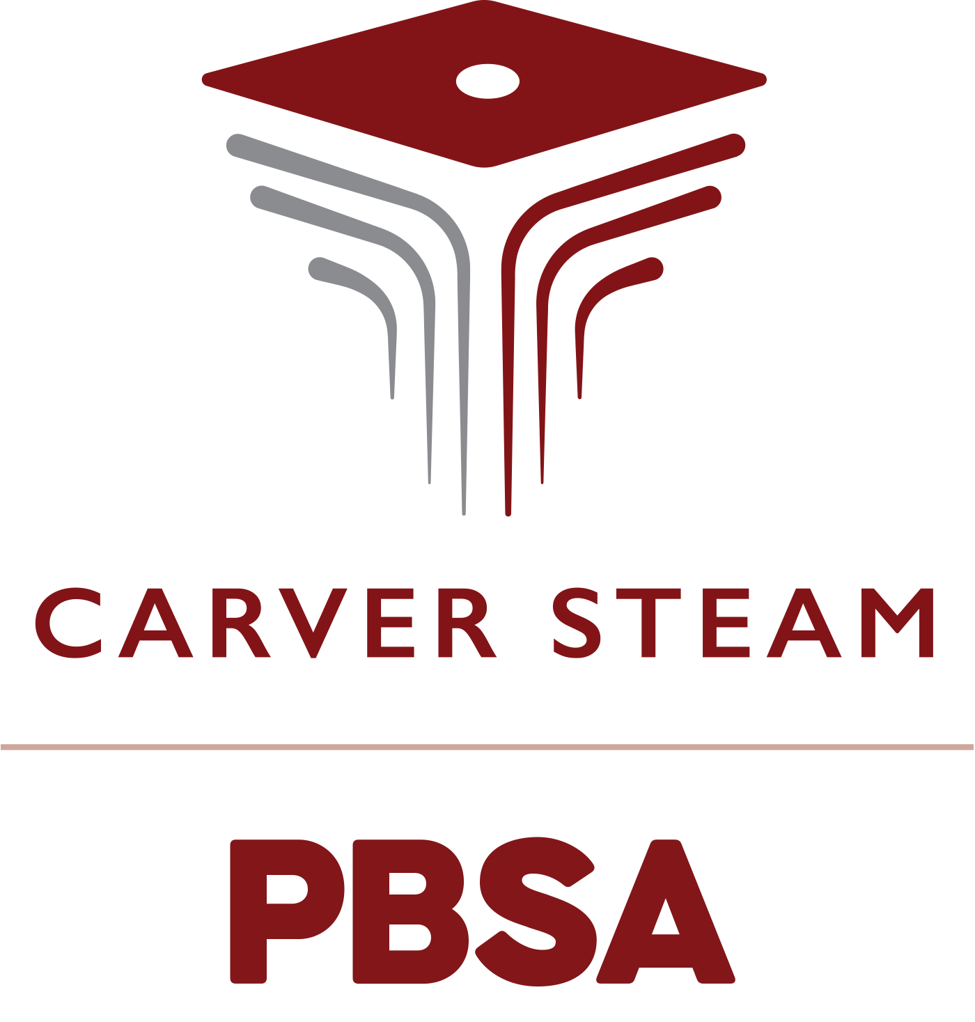

2024-2025

School-Parent Compact for Shared Student Success

***55 McDonough Blvd. SE***

***Atlanta, GA. 30315***

***Phone: (404) 802-4415***

[www.atlantapublicschools.us/carversteam](http://www.atlantapublicschools.us/carversteam)

***Ms. Niomi Henry, Principal***

***Ms. Shambril Manago, Parent Liaison***

***Revised: August. 21, 2024***

Fostering Parent

Partnerships

Parent partnerships are vital to the STEAM Academy at Carver school community and culture. We invite parents to connect with us at following scheduled academic workshops and family engagement events:

* Open House
* Welcome Parent Meeting
* Parent Workshops
* Curriculum Nights
* Education Meetings/ Workshops
* Senior Night
* Rising 9th Grade Information Sessions

Detailed information will be available on the school’s website and the monthly newsletter via emailed to parents.

**What is compact?**

A compact is a written agreement of how school staff, students and parents will work together to help students achieve. Each school that receives Title I money must have a compact.

**What is the purpose of a compact?**

The purpose of a compact is to list specific duties of school staff students, and parents in student learning. With a compact, everyone knows their role. The compact also includes how the school, staff and parents will communicate with each other.

* Teachers will develop lesson plans that cover their grade level’s content standards.
* For other school staff, the compact says what they should do to support the teaching of the content standards and student’s ability to learn.
* The principal will make sure the school is safe and secure so that students can focus on learning, free of disturbance and fear.

**Jointly Developed**

The parents, staff, teachers and community of STEAM Academy at Carver collaboratively developed this school home compact. Meetings are held bi-annually to review the Compact and make changes based on students’ needs. Parents are welcomed to contribute their comments and to volunteer through the Parent Virtual Center located on the school’s website.

What is a School – Parent Compact?

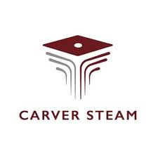 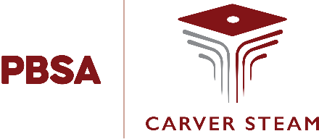

STEAM Academy at Carver is committed to communicating regularly with our families about student learning through the following means:

• Campus Email/Text

• Progress Reports

• Parent-Teacher-Student Conferences

If you have questions about your child’s progress, you may contact the teacher by phone or via their email listed on our school website.

Communication

About Student Learning

*Teachers, students and parents working together towards*

*Student success.*

STEAM Academy at Carver parent/guardians are committed to supporting their child’s learning. Throughout the school year.

***As a Parent I will:***

* Attend Parent Workshops offered by STEAM Academy at Carver to better understand the school goals, assessments my students will be taking, and test preparation strategies I can reinforce at home.
* Ensure my child attends tutorial programs and utilizes online resources in order to receive additional help in preparing for class work and Georgia Milestones.
* Communicate meaningfully and regularly with my child’s teachers regarding his/her progress and additional support needed to meet the goals.
* Monitor my child’s progress using Infinite Campus.
* Communicate regularly with my student’s teachers and provide accurate contact information.

STEAM Academy at Carver scholars are committed to succeeding in school by reaching their personal academic goals.

***As a Student I will:***

* Attend tutorial and utilize online resources to receive additional help and support.
* Use my binder to keep my assignments organized and to stay on task.
* Practice critical thinking by explaining and discussing issues at school and at home.
* Advocate for myself by talking to teachers and adults about what helps me learn.
* Build positive relationships with my teachers.
* Use Infinite Campus to monitor my progress and advocate for myself.

STEAM Academy at Carver faculty and staff is committed working with students and their families to develop student’s Reading competency according to grade level standards.

***As educators and school staff we will:***

* Provide students with interim assessments every six weeks to gauge student readiness for Georgia Milestones.
* Provide students with individualize support based on the results of their assessments. Teachers will adjust their instruction to address learning gaps identified in the interim assessments.
* Provide Georgia Milestones resources and additional online resources for test preparation.
* Provide a climate and culture that is conducive to learning.
* Provide afterschool tutorial to support student success.

School-Parent Compact

My Personal Goal for the School Year:

|  |
| --- |
|  |
|  |
|  |
|  |

**2024—2025 School Academic Goals**

Overall Goal: By the end of school year 2024-2025, STEAM Academy at Carver will yield a **10%** increase in the Proficient category on Georgia Milestones EOCs; **85%** on course pass rate & **90%** on attendance.

**Targeted Goals:**

* 9th grade: **10%** increase in the Proficient Category on 9th grade Algebra 1 EOC
* 10th grade: Yield a **10%** increase in the Proficient Category on Biology EOC
* 11th grade: Yield a **10%** increase in the Proficient Category on American Literature & U.S. History EOC
* 12th grade: Yield an **80%** increase in graduation rate

My Personal Goal for the School Year:

_________________________________________________________________________________________________________________________________________________________________________________